Sybase PowerDesigner
Physical Data Model Report

Model: PERM db
Report: Report 2



Author: Povilas
Version:
Date: 2016-02-15
Summary:

Table of Contents

I PERM database diagram 3
II List of tables 3
II.1 Table USER 3
II.1.1 List of columns of the table USER 3

PERM database diagram
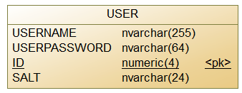

List of tables
Name | Description
User | Stores user as well as user authentication data

Table USER

List of columns of the table USER
Name | Domain | Size | Unique | PK | FK | Index | Null? | Short description
userName | nvarchar | 255 | true |  |  |  | no | User name is user e-mail address.
userPassword | nvarchar | 64 |  |  |  |  | no | Stores user password as SHA256 hashed string.
Salt | nvarchar | 24 |  |  |  |  | no | Random number generated by CSPRNG and added to the user password.
ID | numeric | 4 | true | yes |  | yes | no | User identification.

